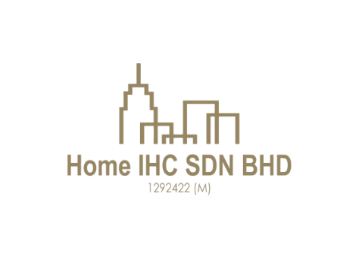
HOME IHC SDN.BHD [201801030396 (1292422-M)]
F-75 Tingkat Atas Jalan Tengku Ismail, 28000 Temerloh Pahang.
(O) 011-630 44931 / 011-100 44931
Email: homeihc22@gmail.com

CUSTOMER PROPERTY VIEWING ACKNOWLEDGEMENT No: 0257

PARTICULARS OF CUSTOMER(S) Date: 27.03.2025
Full Name: Nick  No of pax: 2  Company Name: ELPIJI (M) SDN BHD  Company Address:  601-A, Level 6, Tower A, Uptown 5, 5, Jalan SS21/39,  Damansara Uptown, 47400 Petaling Jaya, Selangor D. E., Malaysia  Car plate no:  Tel (Hp): +60126761818  Called in date: 17-03-2025  Refer to: | Customer’s request: Required 2-3 acres Industrial Factory & Land with TNB Supply: 400amp  Requirement:  Types of Properties: Industrial Factory and Land  Property Link:  Location: Temerloh  Remarks: Currently Industrial Factory has 300amp  Assigned to:
   | MR |  | MRS |  | MS
  iProperty
  Mudah
  Bentongland Website
  Banner
  Whatsapp
  Facebook
   | Agricultural Land
   | Commercial Land |  | Hotel / Resort
   | Industrial Land |  | Factory
   | Residential Land |  | Condominium
  Co-Broke Partner
  Direct Seller

I/We acknowledge and confirm that I/We have visited and inspected the abovementioned property/properties through the efforts and services provided by Home IHC Sdn. Bhd. (Company No: 1292422-M) and Era Realtor Sdn. Bhd. [E(1)2053/1]. Furthermore, should I/We, my nominee, or a nominated company express interest in purchasing the abovementioned property/properties during the site viewing, it shall still be deemed a sale facilitated by Home IHC Sdn. Bhd. and Era Realtor Sdn. Bhd. [E(1)2053/1]. Should I/We, my nominee, or a nominated company in which I/We have an interest or connection, be interested in purchasing any of the abovementioned property/properties, I/We hereby agree not to negotiate directly with the landlord.

_______________________________ _______________________________
Customer Attended staff/representative
Name: Nick Name: Leong Chu Ping
Date: 27.03.2025 Date: 27.03.2025

Property Proposed/ Viewed Date: 27.03.2025

No | Property’s Details | Viewing date | Selling Price | Description
1. | 2.7 acres Mentakab Industry Land For Sale LOT 1745 | 27.03.2025 | Selling Price:  RM 4,000,000 | • Freehold & Industrial  Title  • Connected electrical &  water supply and  Fencing & Gated
2.

If additions, the submission of documents (eg: title, plans) to the prospective customer,

No | Documents | Qty | Signature | Remarks
1. | - Title | 1 set
  GM
  GRN
  HSM
  HSD
  Pajakan Mukim
  Pajakan Negeri
  Topo Plan
  Whatsapp Messenger
  Handover by hardcopy

27.03.2025

